11. To Store Commands, Maintain History Buffer, Handle Capacity Limits, Retrieve Entries, Display History, Validate Consistency.
To Create Pipeline Structures, Store Commands, Maintain Execution Order, Connect Processes, Validate Pipeline Layout, Test Configurations.
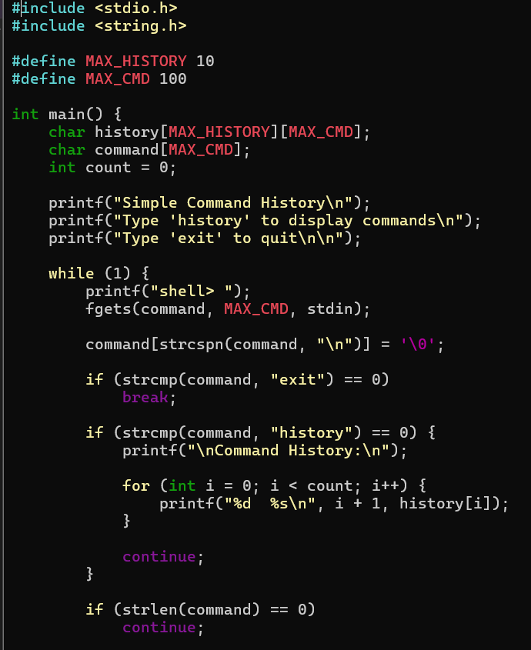
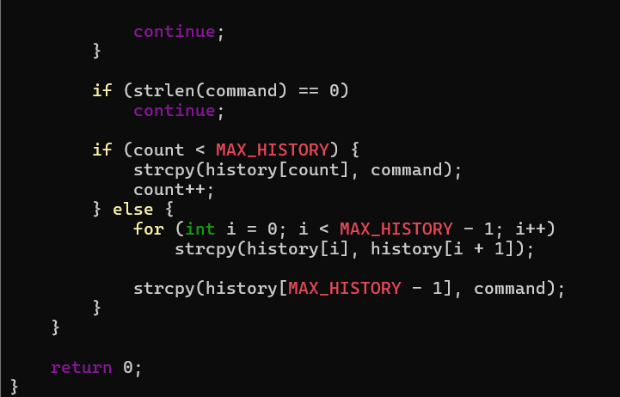
OUTPUT:
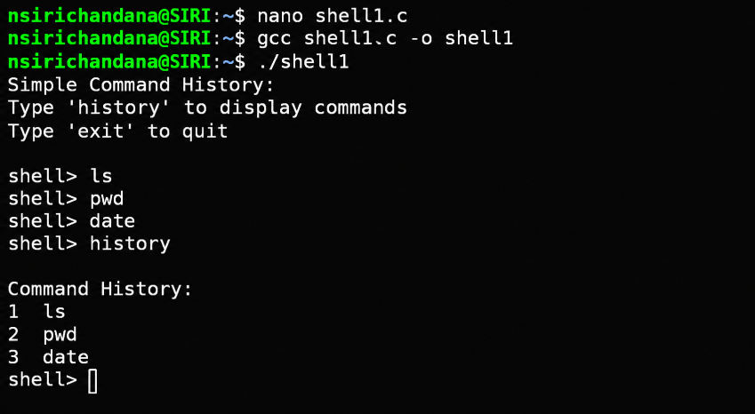
12. To Create Pipes, Redirect Streams, Execute Connected Commands, Close Descriptors, Synchronize Processes, Test Data Flow.
To Support Multiple Pipes, Manage Descriptor Arrays, Launch Multiple Processes, Coordinate Execution, Cleanup Resources, Test Long Pipelines.
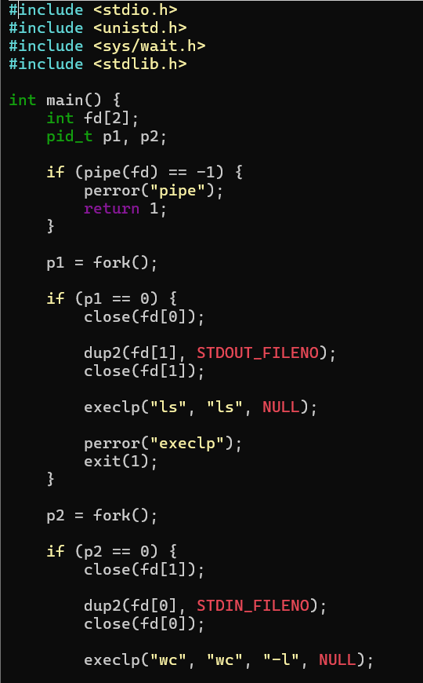
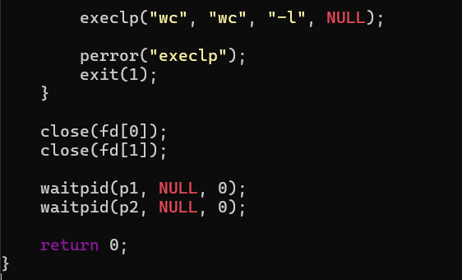
OUTPUT:
